Singles Initial Allocation & Replenishment
Functional Design & User Guide
Landmark Group
in
Planning Allocation, Replenishment & eXecution
(PARX)

Author: Pooja Sharma
Creation Date: Sep 15, 2018
Last Updated: Sep 15, 2018
Document Template Version: 1.0


Title, Subject, Last Updated Date, Reference Number, and Version are marked by a Word Bookmark so that they can be easily reproduced in the header and footer of documents. When you change any of these values, be careful not to accidentally delete the bookmark. You can make bookmarks visible by selecting Tools->Options…View and checking the Bookmarks option in the Show region.

Document Control

Change Record
Date | Author | Version | Change Reference
15-Sep-18 | LMIT | V1.0 | Initial Draft

Reviewers
Name (In order of review) | Position

Distribution
Copy No. | Name | Location
The copy numbers referenced above should be written into the Copy Number space on the cover of each distributed copy. If the document is not controlled, you can delete this table, the Note To Holders, and the Copy Number label from the cover page.
Note to Holders:
If you receive an electronic copy of this document and print it out, please write your name on the equivalent of the cover page, for document control purposes.
If you receive a hard copy of this document, please write your name on the front cover, for document control purposes.
Contents
1.1. Document Control ii
1.2. Introduction 4
1.3. Scope 4
1.4 High Level Process 4
1.5 Singles Initial Allocation and Replenishment 6
1.5.1 Allocation Parameters 6
1.5.2 Buying Plan Reconcilation 6
1.5.3 Common Pool % Distribution 6
1.5.4 Spreading of Approved Planned Initial Allocation & Replenishment 7
1.5.5 Execution of Initial Allocation & Replenishment 7
1.5.6 Release Date Management 8
1.6 Workbook Details for Singles IA and IR 8
1.6.1 Allocation Parameters 8
1.6.2 Buying Plan Reconciliation 10
1.6.3 MDC Common Pool Distribution 13
1.6.4 Singles Initial Allocation & Replenishment Approval 17
1.7 Appendix 22
1.7.1 PARX – RMS Integration 22
1.7.2 Interface Data 23

To update the table of contents, put the cursor anywhere in the table and press [F9]. To change the number of levels displayed, select the menu option Insert->Index and Tables, make sure the Table of Contents tab is active, and change the Number of Levels to a new value.

Introduction
This document describes the functional process of LMG Singles Initial Allocation & Replenishment (PARX) system which is an integrated system for Planning, Allocation, Replenishment and eXecute the user approved planned Initial Allocation to execute Initial Allocation based on ASN or Stock on Hand.

The application is integrated with Planning applications (MFP, AP), analytical system(Netezza) and merchandising system(RMS) to provide end to end solution for driving Store Initial Allocation or Fashion and Basic Items.
Currently the system is already live across Concepts/territories for RDC-Store, MDC-RDC replenishment based on Min Max. The solution has been developed based on analytical findings and multiple simulations for Initial Allocation Process.
The application can be used for,
- Define Allocation Parameters such as Weeks of Cover & Sell Thru%.
- Approve Planned Initial Allocation based on either loaded Buy Qty & Initial Allocation reconciled on PO Qty.
- Approve Planned Initial Allocation based on MFP Pre Ssn Sales Curve/Ly Sales Curve reconciled on PO Qty.
- Review and Update/Set MDC Common Pool Contribution %. Also set RDC Priority in case scarcity situation.
- Execute and Approve the Initial Allocation based on ASN Qty or SOH Qty. Also set an Option as Priority Pick in case of MDC allocations.
- Manage the Release & Ship dates for MDC allocaitons.

Scope
This document describes the process flow and functional design of the system (Phase 1) with end to end user processes supported by relevant screenshots and explanations wherever required. The modules covered are Singles Initial Allocation and Replenishment.

High Level Process
The process starts with approving the Allocation Parameters.
As part of Pre-season process, Concept Planners load the Store/Option Ranging or Store/Option Buy Qty and Initial Allocation Qty. Post that once POs are raised planners approve the planned Initial Allocation and once ASNs are created or Stock on hand is available execute the Initial Allocations based on Planned Initial Allocation and ASN/SOH Quantity.

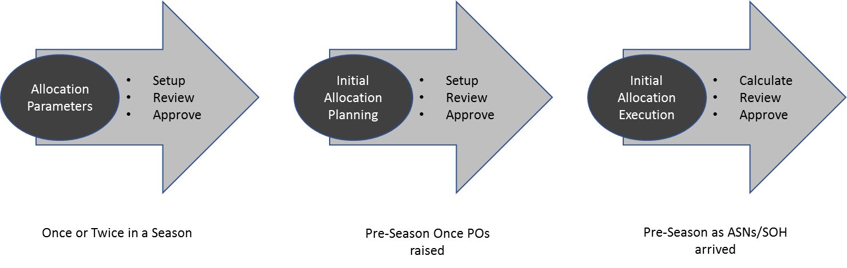

Allocation Parameters - SetUp/Review/Approval: This process will define the following Allocation Parameters.

- Weeks of Cover defined at Class/Location/Product Cluster level is used during the planned initial allocation calculations.

- Sell Thru % defined at Class/Loation/Product Cluster level is used during the planned initial allocation calculations.

Buying Plan Reconciliation: This process allows planners to setup (by means of giving Store/Option Ranging or Store/Option Buy Qty and Initial Allocation) planned Initial Allocation based on PO Qty.

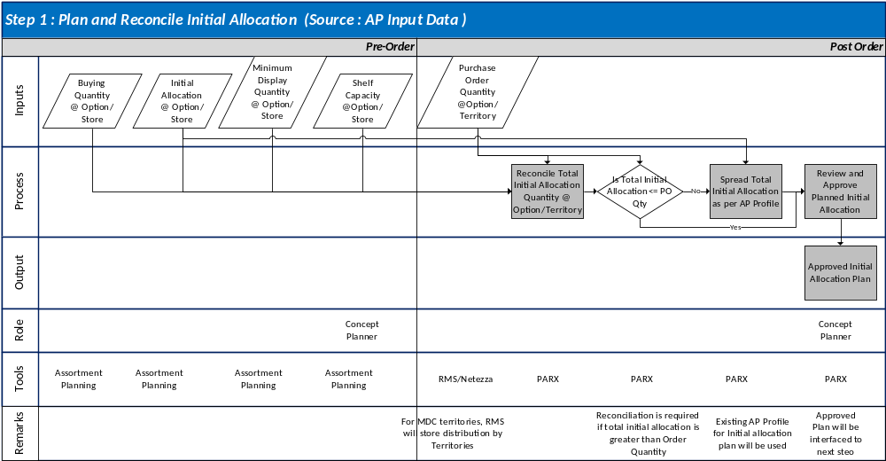
Singles Initial Allocation & Replenishment Approval: This process allows planners finally execute the Initial Allocation based on ASN or SOH Quantity.

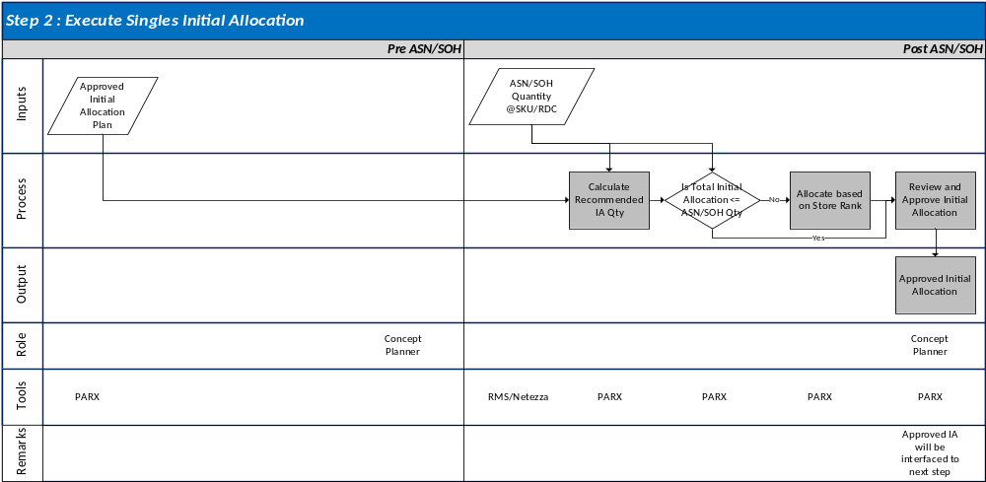

Singles Initial Allocation and Replenishment

1.5.1 Allocation Parameters
Following are the Parameters which are set as part of Allocation Parameters setup process.
- Weeks of Cover – Number of Weeks the Initial Allocation Quantity to Cover based on Planned ROS. The default value set as 4.
- Sell Thru % - Planned/Projected Sell Thru % to calculate realistic Initial Alloction Quantity. The default value set as 80%.
In case happy with the default setup, leave it as is, else change it accordingly and approve the changed values.

1.5.2 Buying Plan Reconcilation
Buying Plan Reconciliation Process is a Pre-Season Process and broadly performed as below.
- Setup – Upload Option/Location Ranging or Option/Location Buy Qty and Initial Allocation.
- Reconciled Buy/Initial Allocation Quantity - In case planner provides a Buy Qty and Initial Allocation and it is greater than the PO Quantity, system then reconciles and forces the PO Quanity on the Buy Quantity and Initial Allcoation Quantiy territory wise.
- Calculated Buy/Initial Allocation Quantity – Based on Ranging Information and missing Buy/Initial Allocation Quantity for a territory system calculates Buy Quanity and Initial Allcoation Quantity. Buy Quantity is calculated as the PO Quanity of the Territory * (MFP Pre-Season Sales Units or Ly Sales Units Shape). Initial Allcoation is calculated based on Planned ROS * Weeks of Cover.
- Initial Replenishment – System also calculates an Initial Replenishment based on Daily ROS * (Lead Time + Review Time) for the stores under MDC except for UAE Stores. Initial Replenishment is not calculated for ASN based allocations.
- Review & Approval – In case system calculates the Buy Qty and Initial Allocation/Replenishment review it & approve it as Planned Initial Allocation. Overrides are allowed in case of system calculated Buy Qty/Initial Allocations with the restrictions as
  - Buy Qty Override can’t go beyond PO Quantity. If overridden for one store, rest of the stores within the territory adjusted automatically and displayed in Final Buy Qty.
  - Initial Allcoation Override Qty can’t be more than the Final Buy Qty of the location.
  - Initial Replenishment Override Qty can’t be more than the (Final Buy Qty – Initial Allocation Qty/Override Qty).

1.5.3 Common Pool % Distribution

Pre-season common pool % distribution setup is a key set up for MDC-RDC distribution engine to define common pool stock at MDC for replenishment in addition to territory allocated stock as per PO distribution.

Territory Distributed Quantity – For every Option, territory distributed PO quantity will be available in RMS for MDC order. This data will be made available by Business based on territory budgeted quantity in PO Upload workflow. SKU/RDC level distribution will be available in RMS in LM_MDC_ORD_TERR_DIST table.

MDC Distributed Quantity – For each Option in a PO, if there is nondistributed PO quantity (MDC Resevered), the information will be also maintained in the above set up as per PO Upload data.

Territory Planned Common Pool (CP) % - Concepts will be responsible to define a common Pool % at Option level from each RDC distributed total PO quantity to build MDC Common Pool Stock. Based on planned % for each option, common pool at MDC will be available for all territories replenishment.
For eg,

Territory | PO Quantity | Initial Allocation | Initial Repl | Available for Repl  (Before CP) | Planned Common Pool % | Common Pool | Available for Repl (After CP)
UAE | 200 | 120 | 40 | 40 | 5% | 2 | 38
QAT | 300 | 160 | 30 | 110 | 5% | 6 | 104
KUW | 300 | 150 | 20 | 130 | 5% | 7 | 123
MDC | 200 | 0 | 0 | 200 | 0% | 215 | 215

During replenishment Orders generation in Min Max Engine, the stock consideration priority for will be as follows during ROQ generation process,

- RDC Distributed Quantity (Available for Replenishment after considering Common Pool contribution)
- MDC Distributed Quantity (Available for Replenishment after considering Common Pool contribution)
- In Order of RDC Priority defined at Concept level.

The planned common Pool % will be approved by Concept Managers in PARX at Option/RDC level. Common Pool contribution will be only applied after Initial Allocation and Initial Replenishment is released from MDC-RDC as shown in the calculations above.

The priority order of MDC-RDC distribution order (as described in section 1.5.1) will be as follows. The stock allocation will follow the sequence as mentioned above.

- Initial Allocation (MDC-Stores)
- Initial Replenishment (MDC-RDC)
- Min Max Replenishment Orders (MDC-RDC)
- Front Load Quantity (MDC-RDC)/Manual Transfer Orders (MDC-RDC)

Concepts to set RDC Prioirty as well to apply to handle the scarcity situations.

1.5.4 Spreading of Approved Planned Initial Allocation & Replenishment

Once the Planned Initial Allocation and Replenishment is approved @ Option/Location level, system then spreads it from Option to SKU based on the available Store Size Profile. In case Store Size Profile missing system then allocates 1 quantity per size for the option. This is an overnight batch process and available only next day.

1.5.5 Execution of Initial Allocation & Replenishment

Once the ASNs are created by Suppliers and visible on PARX or Stock on Hand is available at the MDC, Planners need to review the final Allcoation/Replenishment Quanity and approve it for execution. Once approved at this step, its sent to RMS for distribution.

In case the ASN Quantity is equal to the SKU level Initial Allocation Quantity, system Reccomends the same for execution. But in case of a shortage system then uses the priority ranking of the store based on Initial Allocation quantity and in case of a tie additionally Store contribution to total as a tie break. Users can override the Initial Allocation Quantity for a Store or a set of stores, accordingly remaining stores will be calculated and suggested Initial Allcoation Quantity will be displayed. System does not allow an Initial Allcation Quantity override beyond the ASN/SOH quantity.

In case of Partial Allocation to a store due to shortage/override, user can allocate the remaining once a new ASN/SOH is available.

1.5.6 Release Date Management
System calculates a Release Date & Ship Date based on Planned Launch Date and Store/RDC Lead Times as applicable. In case Planned Launch Date is missing this will not be calculated and planners will need to enter an override to calculate the Release and Ship Date. It is mandatory to have a Release & Ship Date in case of MDC Allcoations. System does not allow approval of initial allcation in case its missing.

Planners can also set an Priority Pick indicator in case an option needs to shipped out ungently from MDC.

Workbook Details for Singles IA and IR
Below workbooks will be accessed by Users to achive Singles Initial Allocation & Replenishment as per the User roles defined.

1.6.1 Allocation Parameters
For Setting the Allocation Parameters such as Weeks of Cover and Sell Thru %, Allocation Parameters workbook is used.
User Roles: Concept Supply Planning Manager
TAB: 2. Allocations → Allocation Parameters
KEY MEASURES IN THE WORKBOOK
Weeks of Cover – Number of Weeks the Initial Allocation Quantity to Cover based on Planned ROS. The default value set as 4.
Sell Thru % – Planned/Projected Sell Thru % to calculate realistic Initial Alloction Quantity. The default value is set at 80%.

Planners need to build the workbook by selecting the required data points to review, set and approve the Weeks of Cover and Sell Thru % parameters.

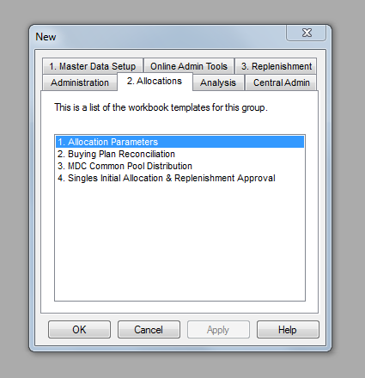
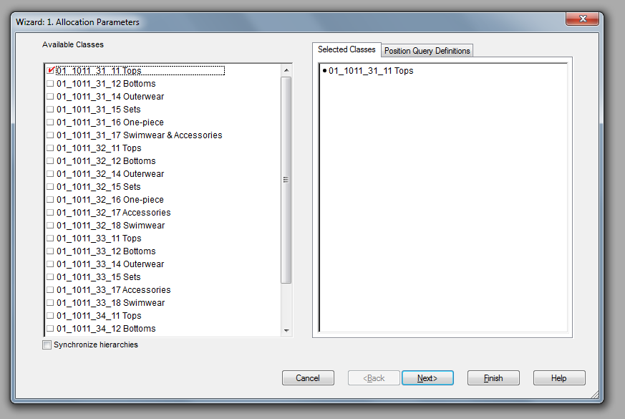

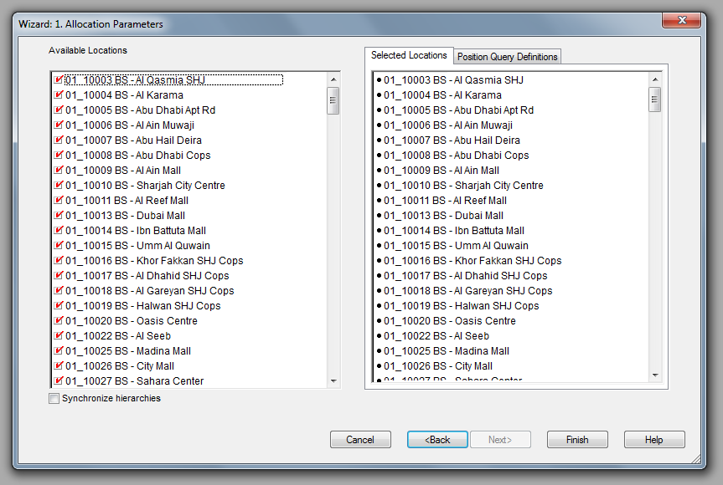
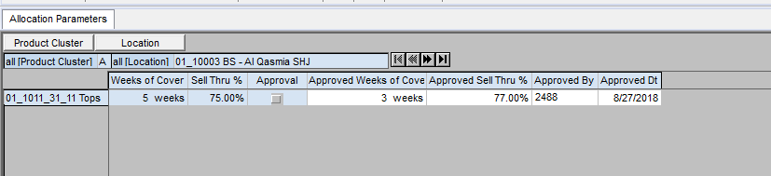

Run the Plannign Action “Approve Allocation Parameters” to approve the changes.

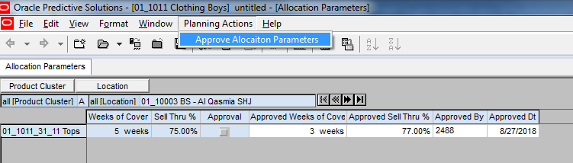

1.6.2 Buying Plan Reconciliation
This workbook is used to review and approv the Buy Quantity, Initial Allocation & Initial Replenishment Quantity Pre-Season.
User Roles: Concept Supply Planner
KEY MEASURES IN THE WORKBOOK
TAB: 2. Allocations → Buying Plan reconciliation
RDC PO Quantity – Total PO Quantity Ordered/Reserved for the RDC.
Pre-Ssn Buy/Initial Allocation Qty – User Input @ Option/Location level.
Reconciled Buy/Initial Allocation Qty – Same as Pre-Ssn Buy/Initial Allocation Qty in case same as PO Qty. In case of shortage, PO Qty is forced on to Buy/Initial Allocation Qty based on the existing shape of Buy Qty and Initial Allocation Qty.
Range Plan – Ranging indication between Option/Location. Users can override this measure to add additional Option/Location Ranging. De-Ranging is not allowed using this measure. in case of de-ranging users will need to upload it through the upload template.
Calculated Buy Qty – System calculated Buy Qty based on PO Qty for the Territory and available MFP Pre-Season Sales Units. Uses can change the curve to Ly Sales Units using the measure Seed Source for Store Distribution measure.
Final Buy Qty – Post any override system calculated Buy Qty.
Unconstrained Initial Allcoation – This is a system calculated Initial Allocation Quantity based on Planned ROS and Weeks of Cover.
Constrained Initial Allocation – This is a system calculated Initial Allocation Quantity after appliying the MDQ and Shelf Capacity constraints.
Initial Replenishment – System calculated Initial Replenishment Quantity based on Daily ROS and Lead Time and Review Time.

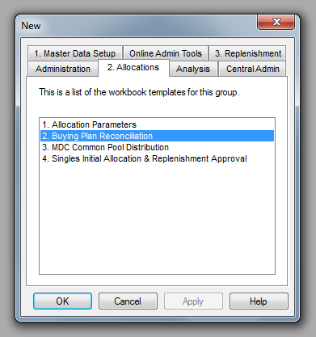

Planners need to build the workbook by selecting the required data points & review and approve either the uploaded Buy/Initial Allocation Quantiy or review and approve the system calculated Buy/Initial Allocation Quantity.

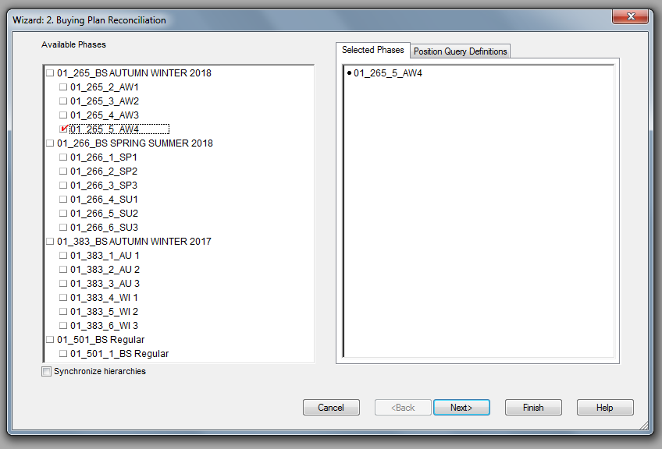

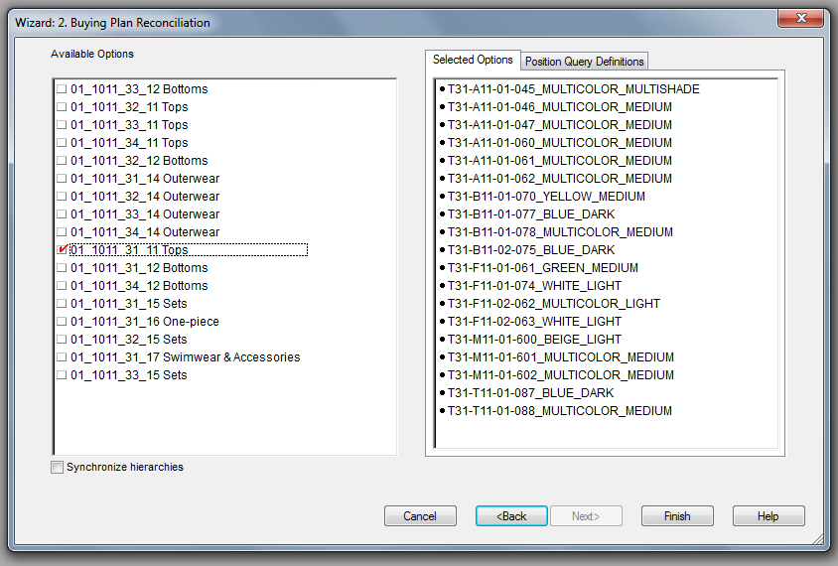

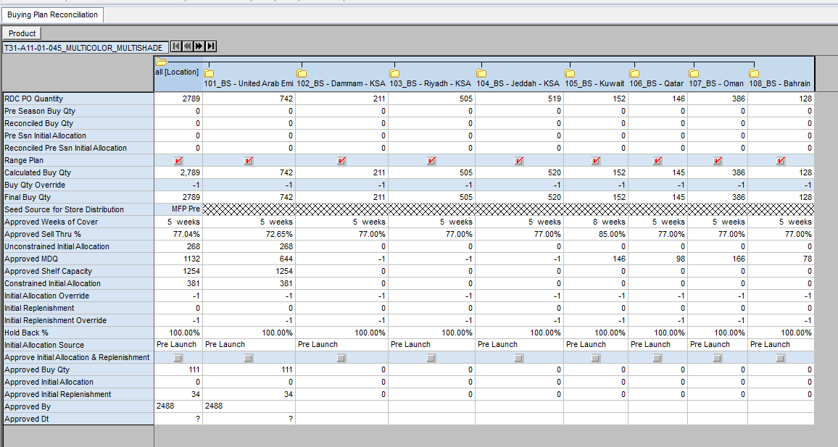

Refer the Reconciled Buy Qty and Reconciled Initial Allocation Quantity in case Buy Qty and Initial Alloction was uploaded for the Option/Territory. Else review the calculated Buy Qty, Final Buy Qty in case Overrides and Unconstrained and Constrained Initial Allocation quantity. Once Happy with the system calculated quantity or the orverrides approve the Planned Initial allocation by selected the measure and running the Planning Action “Approve Initial Allocation and Replenishment”.
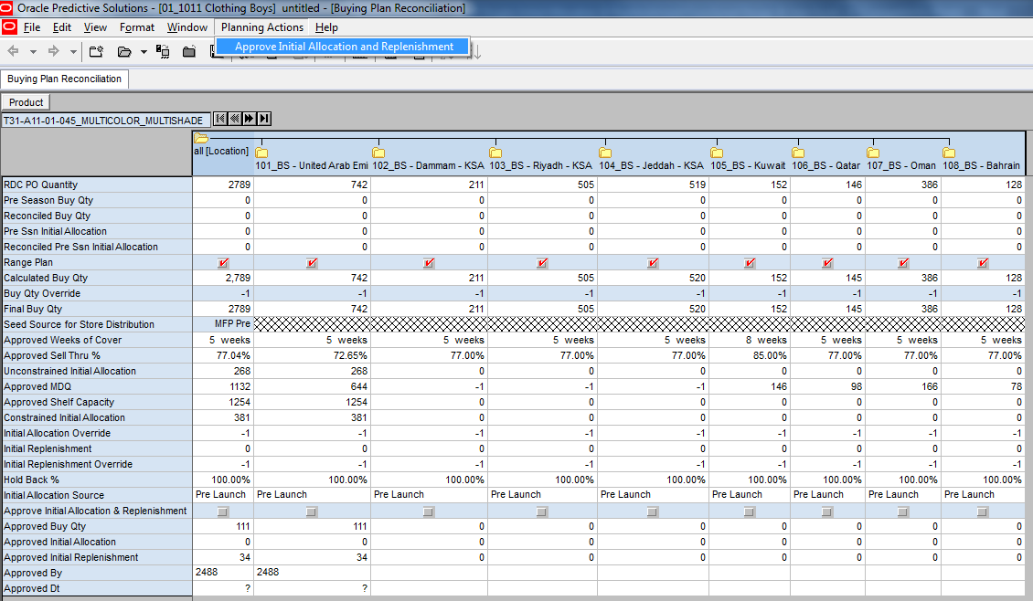

1.6.3 MDC Common Pool Distribution
This workbook will be used by Concept Supply Planner or Concept Admins to define Common Pool Distribution at Option/RDC level. By default, for every Option raised as MDC order and distributed to territories will have 0% common Pool distribution. Concept Supply Planners will be able to amend the contribution at individual RDC/Option (lowest level).

User Roles: Concept Admin, Concept Supply Planner
KEY MEASURES IN THE WORKBOOK
TAB: 2. Allocations → MDC Common Pool Distribution
MDC Non-Distributed PO Quantity – Total Purchase Order quantity raised for MDC not distributed to RDC.
Total Territory Distributed PO Quantity – Total Purchase Order Quantity in MDC Order but distributed to RDC.
Planned RDC Allocated Stock – Total Approved Planned allocation qty in Initial Allocation module
Planned RDC Initial Replenishment – Total Approved Planned Replenishment quantity in Initial Replenishment module.
Planned Reserved Stock for Replenishment – Replenishment Stock left after subtracting Common Pool Stock.

Step 1: Login to the respective local domain/Group, Click “New” and under the tab 2. Allocations, Open 3.MDC Common Pool Distribution and Click “OK”.

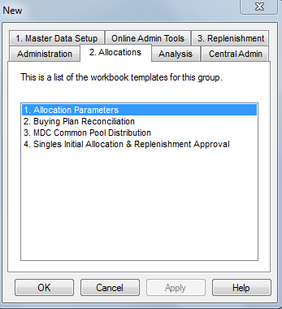

Step 2: Navigate to next step to select available Phases/Seasons to be included in the workbook. Users can select Multiple Seasons/ Phases as per requirement.

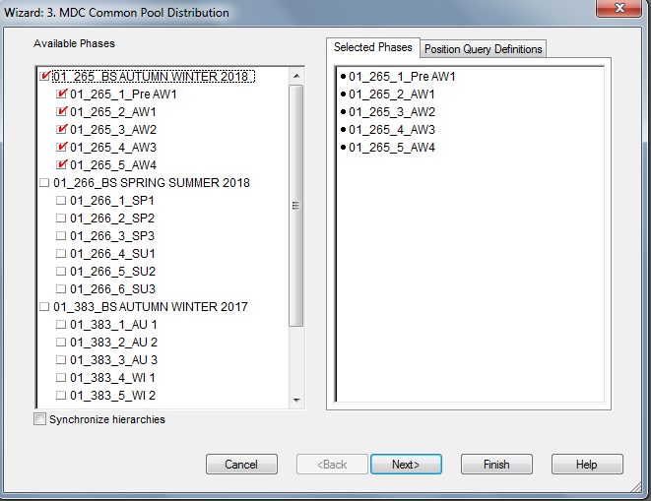

Step 3: In the next step, select Options tagged to the Season/Phase selected in step 2 as shown below. Users will have access to all Option Attributes as available in current version of PARX.

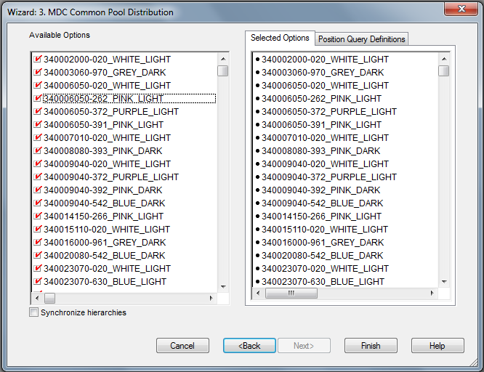

Step 4: Workbook build will be completed and below screen will be shown to the users at Option/RDC level.

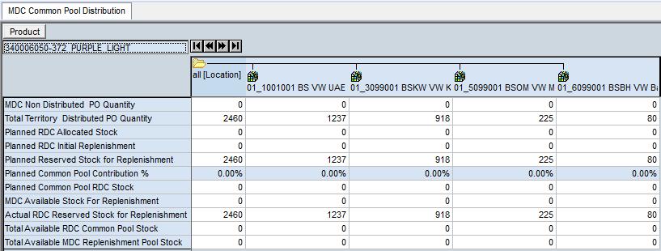

At this point, Users can define the Common Pool Distribution at RDC for all Options/Selected Options in the Planned Common Pool Contribution %.

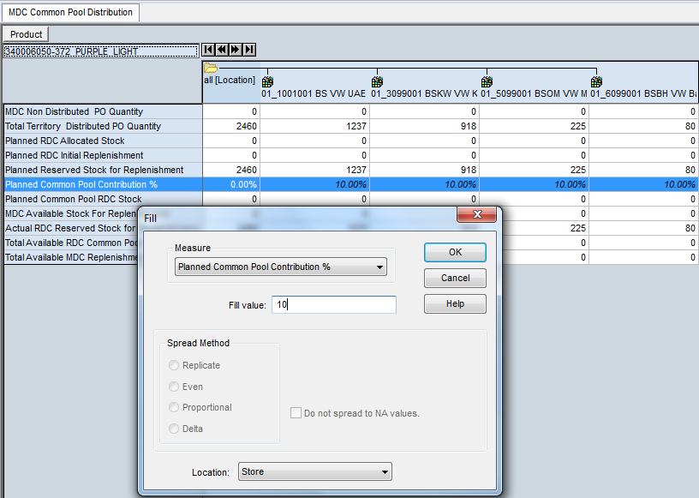

Click Calculate and check the values for RDC Reserved Stock for Replenishment calculated as Planned Reserved Stock for Replenishment – Common Pool %.

The Actuals data will be shown as per actual stock reserved buckets.

Also set the RDC Priority to be used to handle scarcity situations.

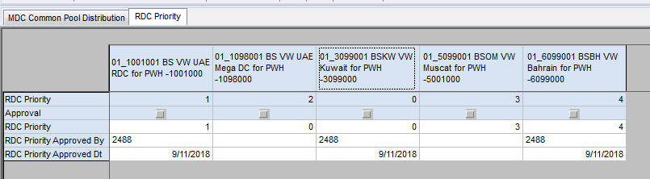

Run the Planning Action “Approve RDC Priority” to approve the RDC Priority. This data then sent to ER for future processing.

1.6.4 Singles Initial Allocation & Replenishment Approval
This workbook will be used by Concept Supply Planner to review and approve the Initial Allcoation quantities for RMS to execute.
User Roles: Concept Supply Planner
TAB: 2. Allocations → Singles Initial Allocation & Replenishment Approval
KEY MEASURES IN THE WORKBOOK
Approved Option Initial Allocation – Pre-Season Approved Option Level Initial Allcoation Quantity
SKU Pre-Season/Pre-Launch Initial Allocation – System calculated Initial Allocation Quantity based on Loation Size Profile.
RDC ASN or MDC/RDC SOH – Contains the ASN Quantity or SOH Quantity.
Reccomended Order Quantity – System calculated Allocation based on ASN Quantity. In case of shortage Store Ranking is applied to reconcile to ASN Quantity. To see the recommendation users will need to run the Planning Action “Calculate ASN/SOH Allocation”.
PARX Allocatoin Status – This measure shows whether the Option/Location is fully allocated or not.

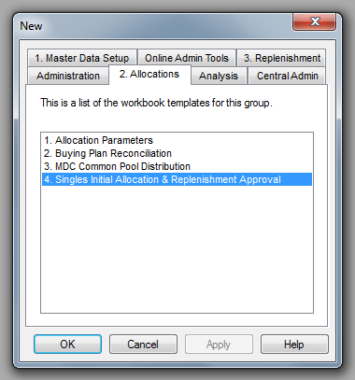

Planners need to build the workbook by selecting the required data points & review and approve the Initial Allcoation and Replenishment for RMS to execute.

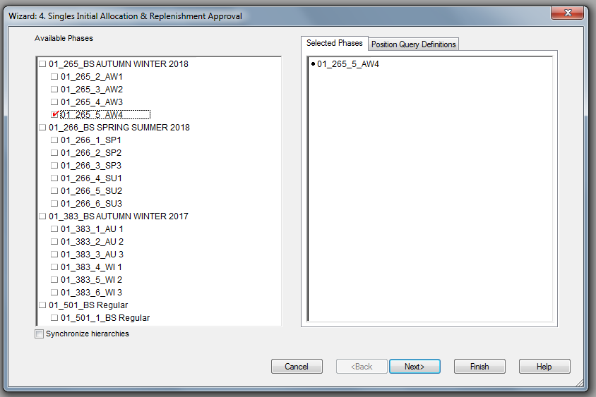

Max one RDC.

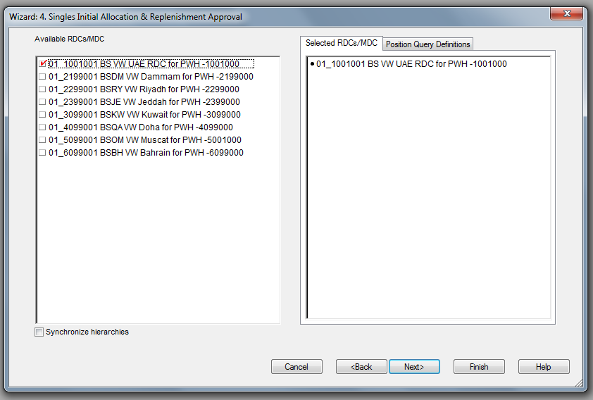

Select POs for ASN based allocation, Stock On Hand for SOH based allocation.

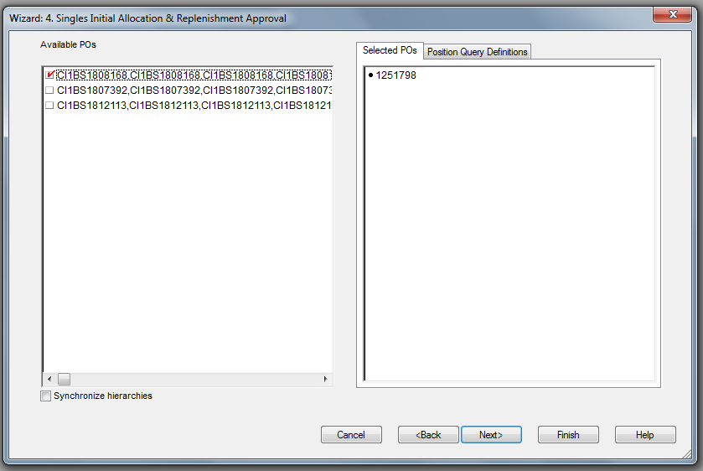
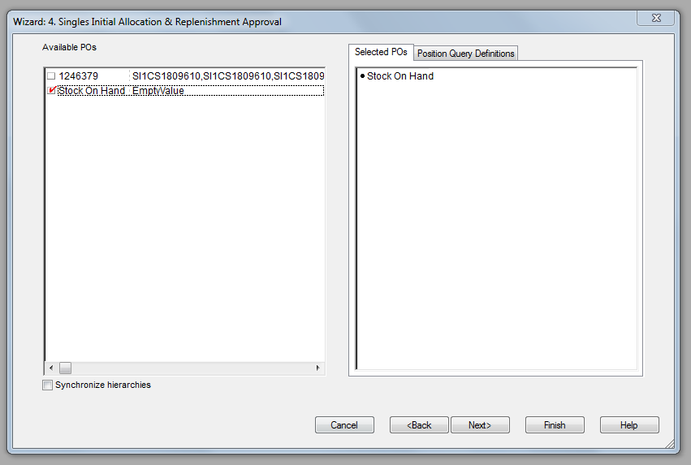

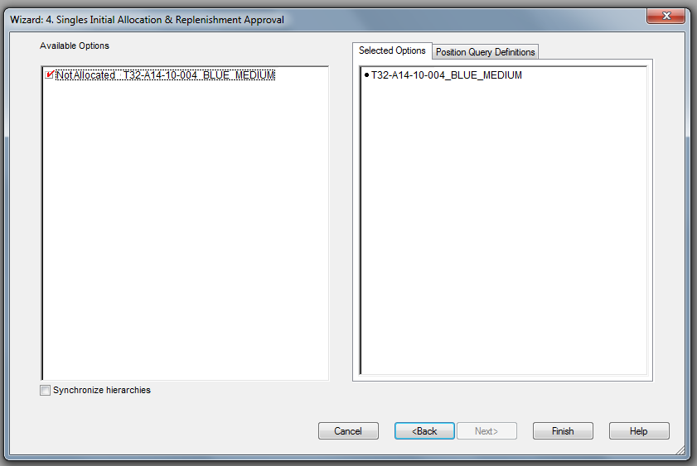

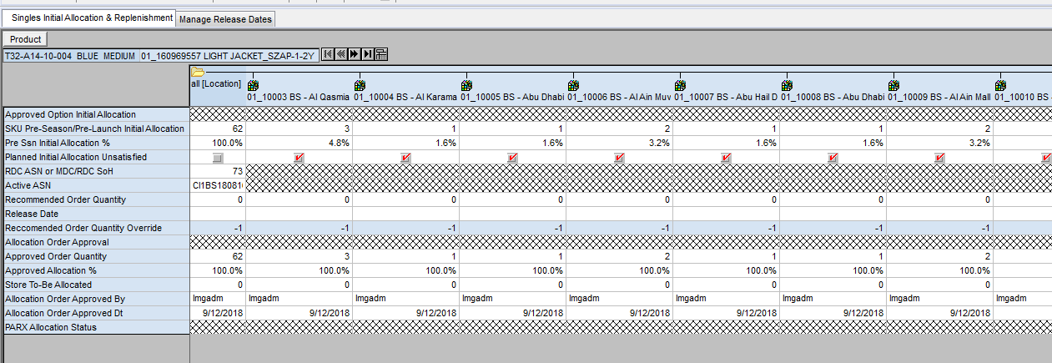

Run the Planning Action “Calculate ASN/SOH Allocation” to calculate Reccomended Order Quantity. Store Ranking to be applied in case of shortage in ASN/SOH Quantity.

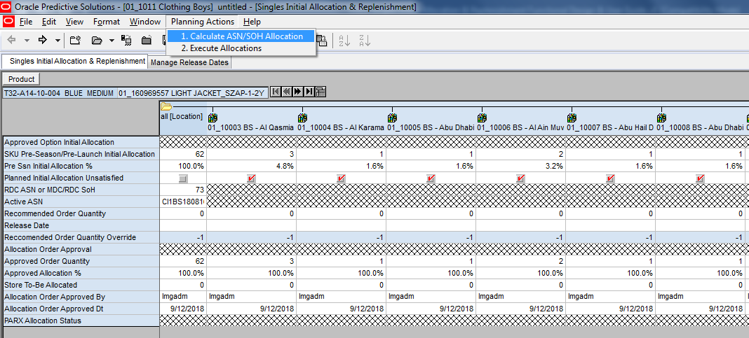
Planner will need to review the Reccomended Order Quantity, Override if needed and then approve it for execution. Run the Planning Action “Execute Allocations” after selecting the Option which needs to be approved.

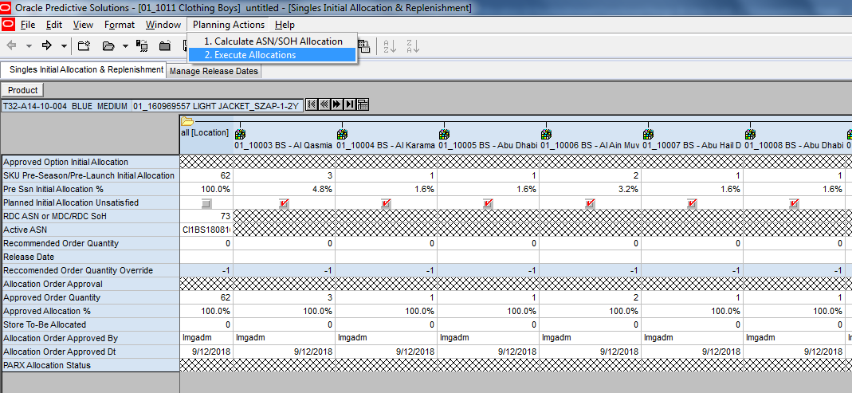

Appendix
Below are some key calculations with appropriate examples to under the Min-Max generation and approval process.

PARX – RMS Integration
Initial Allcoation approved files will be interfaced to RMS only one time in a day post Business Hours. There is no multi slot planned.
Sample Outbound attached.

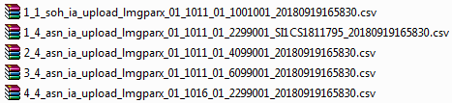

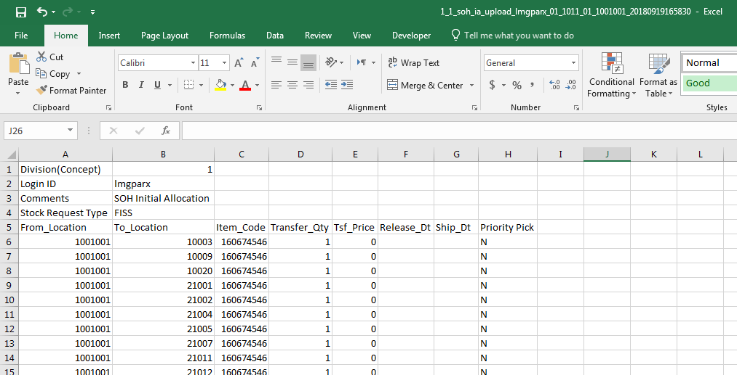
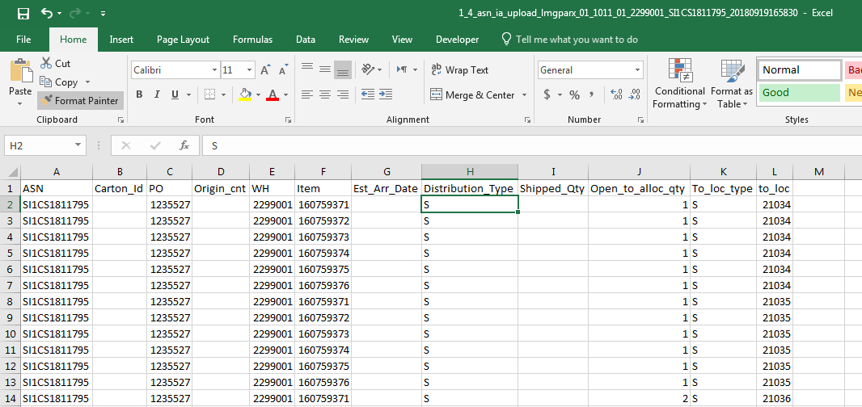

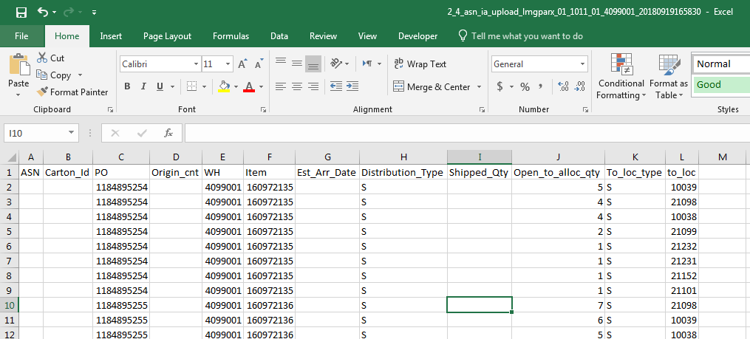

Interface Data
Data | Interface name | Intersection | Description
Hierarchy | Prod Hierarchy | sku
Hierarchy | Loc Hierarchy | loc
Hierarchy | DC Hierarchy | wh
Hierarchy | Season Hierarchy | phase
Hierarchy | WH Hierarchy | cdc
Hierarchy | PO Hierarchy | PO
Hierarchy | Size Hierarchy | size
Hierarchy | repl_status | sku/store | 1.MinMax Active  2.Min Max not Set (Item-Loc Ranged/Trading but no Min/Max set by Users)  3.MinMax need review ( Current week ROS is higher/Less than last week ROS)  4.MinMax Stopped (Item-loc replenishment stopped due to expired Planned Exit Date/Consolidation)
Store-Size Profile | store-size Profile | season/subclass  /store  /size_range/size | Store-size profile calculated in Netezza based on PO Ratio
Service level | Service level | sku/store | Recommended service Level based on Sellthorugh Index for each SKU/Store
Lead Time | Average Lead Time | store | Average Lead Time for store based on last 6 months transactions interfaced from Netezza
Lead Time | Lead Time Variance | store | Variability in Lead Time for each store based on last 6 months transactions.
Launch Attributes | Ranged( T/F) Value | option/store | sku/store ranging information
Launch Attributes | Store Receive Date Value | option/store | Store receive date in RMS
Launch Attributes | First Sold date Value | option/store | First Sale date in RMS
Launch Attributes | Planned Exit Date Value | option/store | Planned Exit Date -To be calculated in Netezza
MinMax Input | Daily Average ROS Value | sku/store | daily average demand based on actuals - (Last 2 Months for Basics)
Data | Interface name | Intersection | Description
MinMax Input | ROS Variability Value | sku/store | demand variability based on Actual sales data
MinMax Input | Planned ROS Value | sku/store | Forecasted daily average demand.
RMS Min Max | On RMS T/F | sku/store | On RMS Min/Max Indicator
RMS Min Max | RMS Effective Date From | sku/store | RMS Min/Max details
RMS Min Max | RMS Effective Date To | sku/store | RMS Min/Max details
RMS Min Max | RMS Min (100) | sku/store | RMS Min/Max details
RMS Min Max | RMS Max (100) | sku/store | RMS Min/Max details
SKU Attributes | Season | sku | RMS Min/Max details
SKU Attributes | Hit-Phasing | sku | Hit Information
SKU Attributes | Product-Type | sku | Product Type UDA Value
SKU Attributes | All- Product Lifespan | sku | Lifespan UDA Value
SKU Attributes | Size_Range | sku | Size Range lined to the sku
SKU Attributes | Size | sku | Size Information
Data | Interface name | Intersection | Description
PO | PO Quantity | SKU/Location/PO | Purchase Order Hierarchy
Stock | MDC Stock | SKU/Location | MDC Closing Stock
Allocations | Canceled | SKU/Location/Alloc ID | Canceled Allocations
Allocations | Status | Option/Location | Allocation Status
Curve | Ly Sales Unit | Class/Location/Season | Last Year Like Season Sales Units
Curve | MFP Pre-Ssn Sales Unit | Class/Location/Season | MFP Pre-Ssn Sales Units
ASN/SOH | RDC ASN or MDC/RDC SOH | SKU/Location/PO | RDC/MDC ASN or MDC/RDC Stock On Hand Quantity
ASN/SOH | ASN ID | SKU/Location/PO | ASN ID
ASN/SOH | Allocation ID | SKU/Location/PO | Allocation ID
ASN/SOH | Container ID | SKU/Location/PO | Container ID

